**Choose the letter of the correct answer. In all cases, E) NOTA means “none of these answers”. You have 60 minutes to complete this test. Figures are not drawn to scale.**

1) Dug chases a squirrel uphill from point (-2, -1) to (1, 3). What is the distance that he ran?

**A. 25 B. 7 C. 5 D.  E. NOTA**

2) What is the geometric mean of 2 and 32 plus the arithmetic mean of 2 and 32?

**A. 25 B. 34 C. 68 D. 98 E. NOTA**

3) Mr. Fredrickson takes Russell to Lawton Chiles High School for the Mini Mu Competition. The flagpole outside is 21 feet tall and it casts a shadow of 6 feet. Russell's shadow is 14 inches long, how tall is Russell?

**A. 3 foot 1 inch B. 4 feet C. 4 foot 1 inch  
D. 5 feet E. NOTA**

4) If Kevin has baby chicks, then Kevin is a girl. What is the converse of this statement?

**A. If Kevin does not have baby chicks, then Kevin is a girl.  
B. If Kevin does not have baby chicks, then Kevin is not a girl.  
C. If Kevin is a girl, then Kevin has baby chicks.  
D. If Kevin is not a girl, then Kevin does not have baby chicks.  
E. NOTA**

5) In an obtuse triangle, how many of the three altitudes fall outside of the triangle?

**A. 0 B. 1 C. 2 D. 3 E. NOTA**

6) Dug is resting with Mr. Fredrickson in the park when he spots a squirrel. He runs 2 meters due north before running 8 meters due west, another 14 miles due south, and 3 miles due east. Provided that Mr. Fredrickson has not moved, how far is the shortest path back to Mr. Fredrickson, in meters?

**A. 5 B. 13 C. 26 D. 38 E. NOTA**

7) What is the point of concurrency of the medians in a triangle?

**A. centroid B. circumcenter C. incenter D. orthocenter  
E. NOTA**

8) Russell wants to blow up a picture of Kevin. The original picture is 3 inches by 5 inches. He wants to increase the area to 60 sq inches. What is the length of the longest side of the new picture?

**A. 6 B. 10 C. 15 D. 30 E. NOTA**

9) Which of the following cannot be the three sides of a triangle?

**A. 3, 4, 5 B. 4, 6, 9 C. 2, 5, 6 D. 6, 7, 13   
E. NOTA**

10) If ABC ~ DEF, AB = 26, BC = 67, AC = 89 and DE = 6, find the perimeter of DEF.

**A. 36 B. 42 C. 169 D. 182 E. NOTA**

11) Which of the following case(s) can the Law of Sine be used in to solve a triangle?

I. SSS  
II. AAS

III. ASA

IV. SAS

**A. I B. II & III C. I & IV D. II, III & IV  
E. NOTA**

12) Parallelogram GAME has diagonals and  that intersect at point Y. If GM = 8a,

EY = 2a + 4, AY = 3b -3, and GY = 3b + 1.What is a + b?

**A. 20 B. 16 C. 11 D. 9 E. NOTA**

13) Which of the following properties is not always true for a rhombus?

**A. All four sides are congruent.**

**B. Each diagonal of a rhombus bisects a pair of opposite angles.**

**C. The diagonals of a rhombus are perpendicular.  
D. The diagonals are congruent.  
E. NOTA**

14) In order to become a Senior Wilderness Scout Russell has to be able to draw a quadrilateral on graph paper. He draws quadrilateral PINK with vertices P(1, 0), I (4, -1), N(3, -4), K(0, -3). What type of quadrilateral did Russell draw?

**A. Kite B. Rectangle C. Rhombus D. Square E. NOTA**

15) What is the sum of the exterior angles in an icosagon?

**A. 20 B. 360 C. 880 D. 3240 E. NOTA**

16) The ratio of the area of two similar triangles is 64:25. The perimeter of the smaller triangle is 20. What is the perimeter of the larger triangle?

**A. 59 B. 40 C. 32 D. 27 E. NOTA**

17) If a polyhedron has 88 edges and 36 faces, how many vertices would it have?

**A. 54 B. 62 C. 88 D. 124 E. NOTA**

18) A right angle is bisected and then trisected. Which of the following could not be the degree of an angle formed by any two of the rays?

**A. 15 B. 35 C. 60 D. 75 E. NOTA**

Use the figure below for questions 19 and 20.

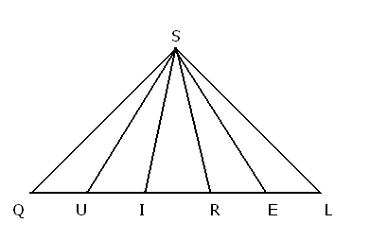

SQL is isosceles, SUE is equilateral and SIR is isosceles. =120°

19) What does = ?

**A. 15° B. 24° C. 30° D. Not enough information E. NOTA**

20) What does = ?

**A. 14° B. 72° C. 88° D. 108° E. NOTA**

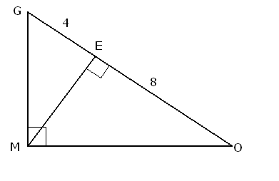

21) If = 4, = 8, find .

**A. 4 B.  C. 6 D.  E. NOTA**

22) Using the triangle below, what is ?

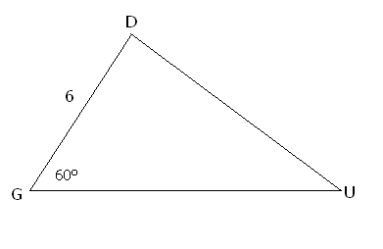

**A. 8 B. 12 C. 16 D. Not enough information E. NOTA**

23)  is complementary to , is supplementary to , and the ratio of to is 2:11. What is ?

**A. 10 B. 70 C. 90 D. 110 E. NOTA**

24) If the diagonals of a rhombus are 12 and 24, what is the radius of the circle inscribed inside of the rhombus?

**A.  B.  C.  D. Not enough information  
E. NOTA**

25) Russell is taking a math test. One of the questions asks for the area of a triangle with side lengths 6, 7, and 11. Find the area of that triangle.

**A. 33 B.  C.  D. Not a triangle E. NOTA**

26) Dug has a toy ball whose volume is the same as its surface area (excluding units). What is the radius of the toy ball? Assume the radius is greater than zero.

**A. 1 B. 2 C. 2.5 D. 3 E. NOTA**

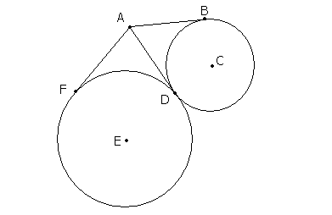



27)  and  are tangent to circle C.  and  are tangent to circle E.  = x + 24,

=5x + 8, what does  = ?

**A. 15 B. 23 C. 45 D. 47 E. NOTA**

28) What is the radius of a circle with the equation - 6x + + 4y = 23?

**A. 4 B. 6 C. 23 D. 36 E. NOTA**

29) What is the surface area of a cone with a height of 15 inches and a slant height of 17?

**A. 155π B.  π C. 200π D. 255π  
E. NOTA**

30) Mr. Fredrickson buys Russell a cone shaped piece of chocolate with a radius of 5 and a height of 10 for Christmas. However, Russell wants to split the chocolate evenly with Kevin. Mr. Fredrickson cuts the circular cone parallel to its base so that the two resulting pieces have equal volume. What is the height of the piece which is a cone?

**A. 5 B.  C. 4 D. 5 E. NOTA**